# MODULE 03 Understanding Hard Disks and File Systems

# LAB SCREENSHOTS

Lara Alofi

2110886

Y

Computer Hacking Forensic Investigator (CHFI)

Lab Session Identifiers

1. <https://labclient.labondemand.com/LabClient/c398319e-2459-4f70-abd8-ac577bbf7ee5>
2. <https://labclient.labondemand.com/LabClient/b2a7f009-5808-49ee-ad90-41f5b349e0af>

Username on EC-Council System

1. 2110886@uj.edu.sa

Lab 01

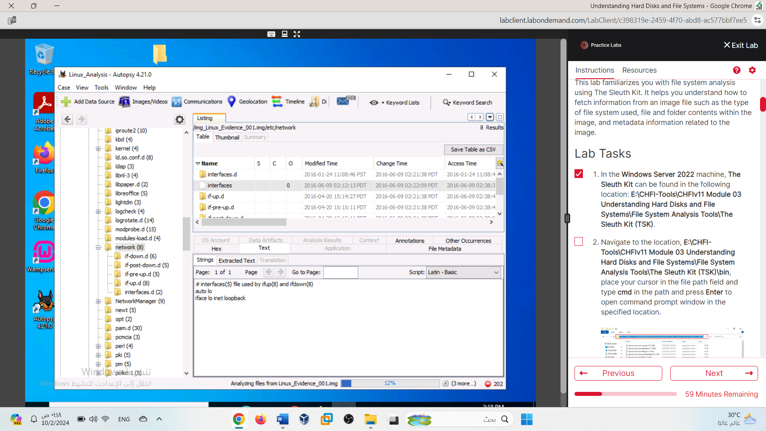

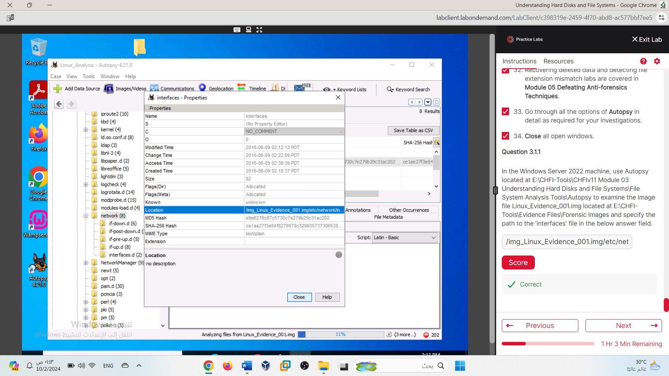

/img_Linux_Evidence_001.img/etc/network/interfaces

Lab 02

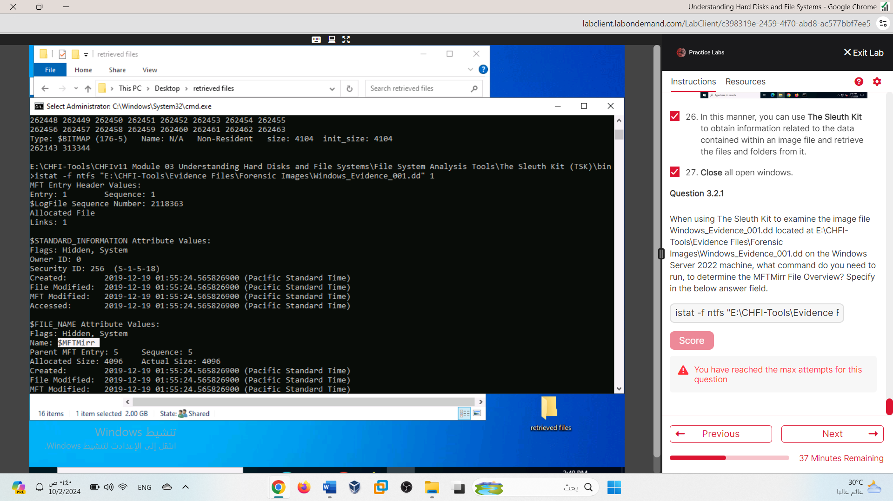

I opened a new session after completing the lab and submitted the same answer again because this session did not accept my response.

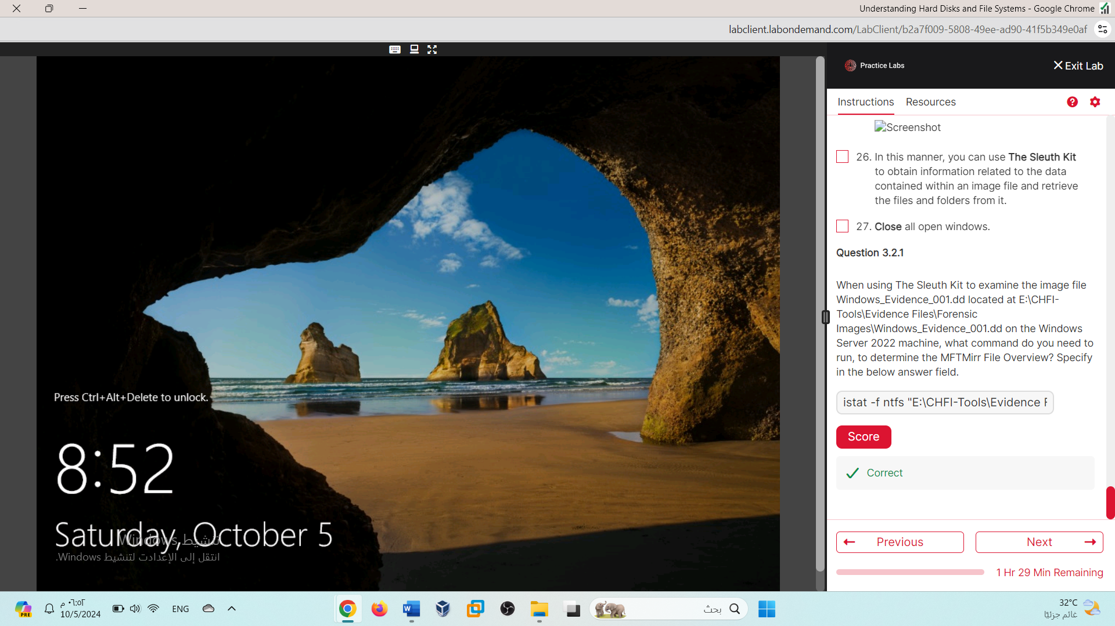

istat -f ntfs "E:\CHFI-Tools\Evidence Files\Forensic Images\Windows_Evidence_001.dd" 1

Lab 03

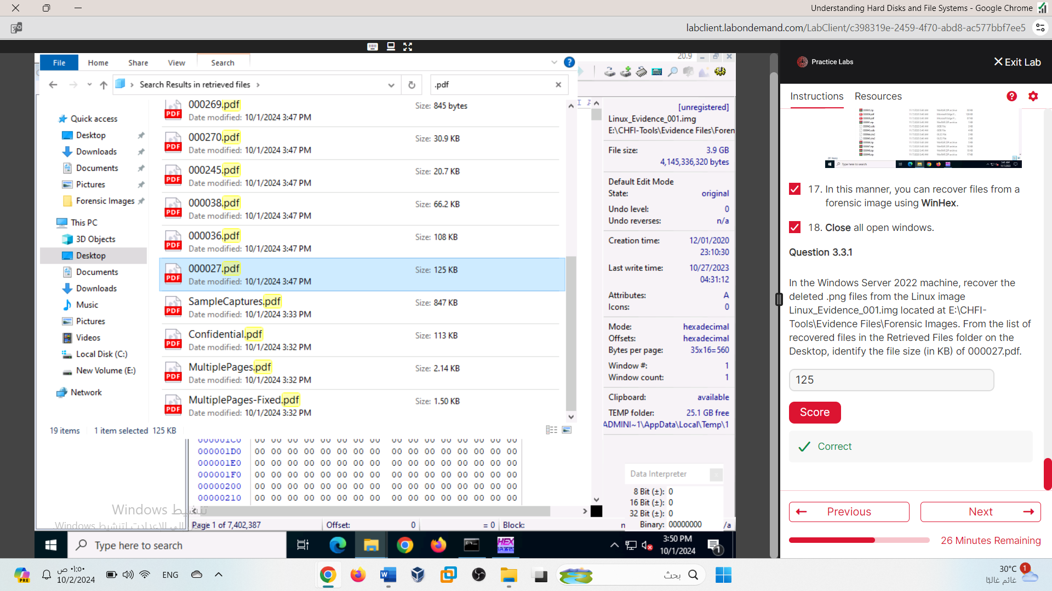

Lab 04

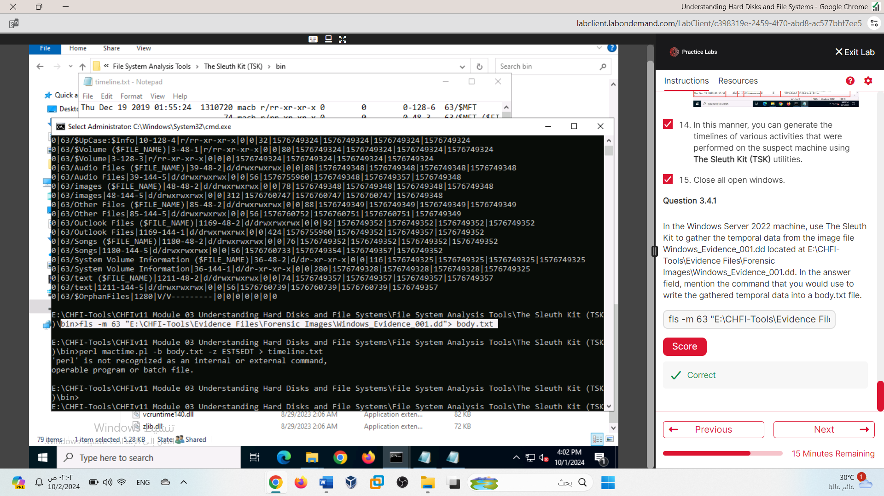

fls -m 63 "E:\CHFI-Tools\Evidence Files\Forensic Images\Windows_Evidence_001.dd" > body.txt

Lab 05

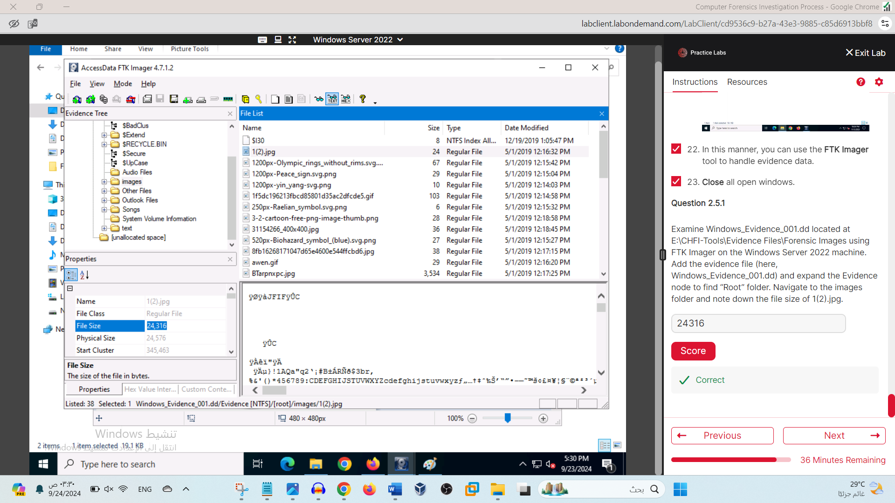

Lab 06

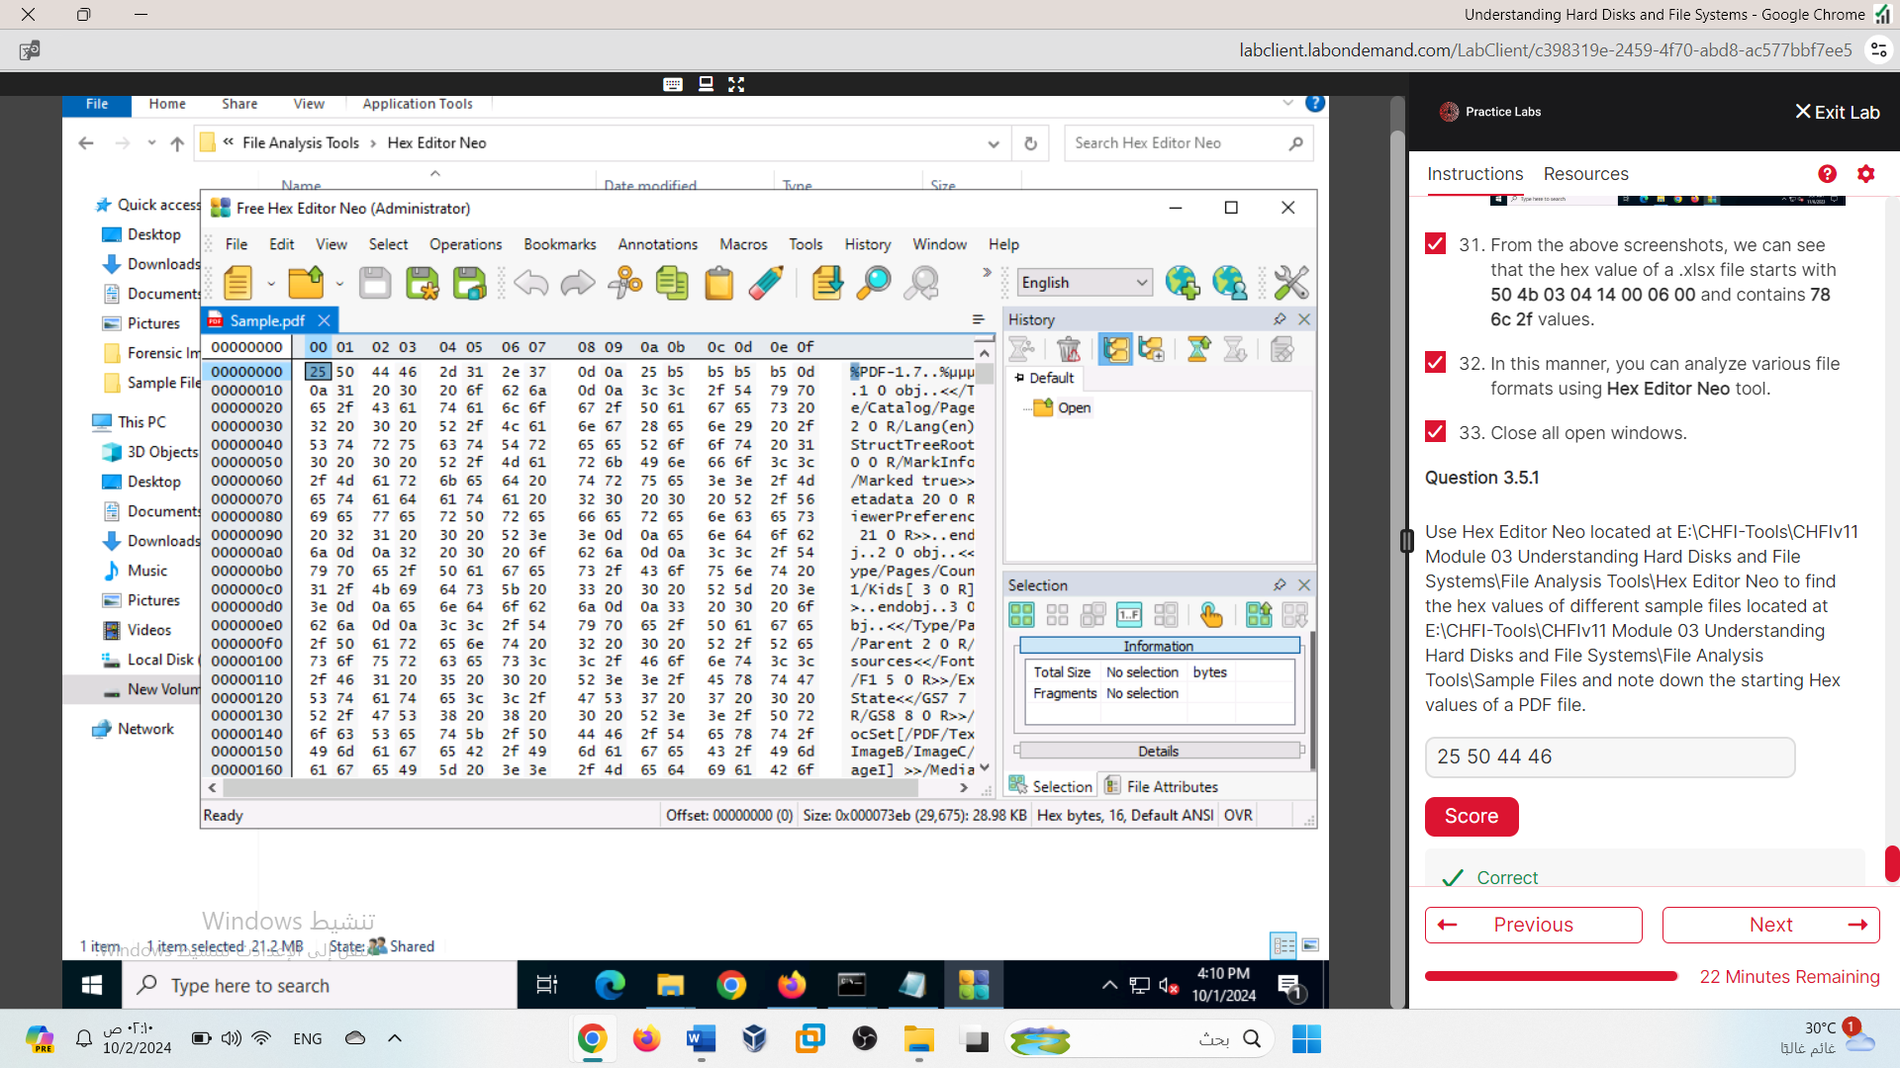

25 50 44 46

